Heal the Bay Giving Tuesday Toolkit

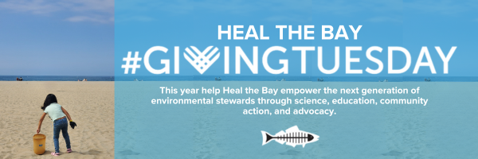
We only have a few days left until Giving Tuesday! Please contact your network(s) and share these assets to get your friends, family, and social media followers excited. We have the opportunity to empower thousands of LA students through science, education, and community outreach with our Giving Tuesday Toolkit but we can’t do it without you.

Email Template:
Dear ____ ,

Will you please join me this #GivingTuesday to support Heal the Bay? Every year, Heal the Bay and Heal the Bay Aquarium provide crucial public health and educational resources to thousands of students across LA County. On November 28, 2023, you can empower the next generation of marine scientists, climate justice activists, and community organizers by donating to Heal the Bay’s Giving Tuesday Campaign.

Share this message with your community to help keep environmental education equitable and accessible for all. https://donate.healthebay.org/campaign/giving-tuesday/c156083

DOWNLOAD IMAGES:
https://healthebay.org/wp-content/uploads/2023/11/Email-Giving-Tuesday-2023.png
https://healthebay.org/wp-content/uploads/2023/11/Email-2-Giving-Tuesday-2023.png

Instagram Template:
This #GivingTuesday, I am supporting @HealtheBay’s mission to empower the next generation of environmental stewardship through science, education, community action, and advocacy. On Tuesday, November 28, 2023, impact the lives of thousands of students in LA County by donating to Heal the Bay’s Giving Tuesday Campaign! Link in bio https://donate.healthebay.org/campaign/giving-tuesday/c156083

DOWNLOAD IG IMAGE: https://healthebay.org/wp-content/uploads/2023/09/IG_HTB-Giving-Tuesday-2023.jpg

Twitter Template:
This #GivingTuesday I'm supporting @HealtheBay in their mission to bring science, advocacy, and hands-on environmental education to thousands of students across LA County. Join me in donating to their campaign! https://donate.healthebay.org/campaign/giving-tuesday/c156083

DOWNLOAD TW X IMAGE: https://healthebay.org/wp-content/uploads/2023/11/TW-X-_HTB-Giving-Tuesday-2023.jpg

Facebook Template:
This #GivingTuesday, I am supporting @HealtheBay’s mission to empower the next generation of environmental stewardship through science, education, community action, and advocacy. On November 28, 2023, impact the lives of thousands of students in LA County by donating to Heal the Bay’s Giving Tuesday Campaign: https://donate.healthebay.org/campaign/giving-tuesday/c156083

DOWNLOAD FB IMAGE: https://healthebay.org/wp-content/uploads/2023/11/FB_HTB-Giving-Tuesday-2023.jpg

